Combinatorics HW 1.1

Student ID: **2018280070** Name: **Peter Garamvoelgyi** Score:

1. **A T-shirt will be printed with a magic square of size 3. How many different prints are possible?**

Let us regard the problem with variables representing the missing values:

$$\left[\begin{matrix}a & b & c \\ d & e & f \\ g & h & i\end{matrix}\right]$$

We know that for a 3x3 magic square

$$M=\frac{n(n^{2}+1)}{2}=15$$

… and all values are drawn from the set $D=\left\{1,2,…,9\right\}$.

Let us regard the magic square constraints for row 2, column 2, and the diagonals:

$$d+e+f=15$$

$$b+e+h=15$$

$$a+e+i=15$$

$$c+e+g=15$$

Adding them together, we get:

$$\left(a+b+c+d+e+f+g+h+i\right)+3e=60$$

We know that

$$a+b+c+d+e+f+g+h+i=\frac{9∙(9+1)}{2}=45$$

Thus we get

$$e=5$$

… meaning that **the middle element of any 3x3 magic square must be 5**.

Let us enumerate all the possible triplets $\left(x,y,z\right)$ s.t.

$$\left(x,y,z\right)∈D×D×D, x≠y, x≠z, y≠z, x+y+z=15$$

The 8 possible triplets are

$$1+5+9 (1)$$

$$1+6+8 (2)$$

$$2+4+9 (3)$$

$$2+5+8 (4)$$

$$2+6+7 (5)$$

$$3+4+8 (6)$$

$$3+5+7 (7)$$

$$4+5+6 (8)$$

The triplets containing $5$ ($(1)$, $(4)$, $(7)$, and $(8)$) must pass through the middle, i.e. these triplets must describe the 2nd row, the 2nd column, and the two diagonals.

Let us notice, that for each value in the corners, we need 3 triplets: one for the row, one for the column, and one for the diagonal. As the values 1, 3, 7, 9 only appear in two-two triplets, **the values in the corners must be 2, 4, 6, and 8**. Thus the equations for the diagonals must be

$$2+5+8 (4)$$

$$4+5+6 (8)$$

We can arrange these 2 diagonals in 8 different ways, based on the order of the diagonals ($2$ possibilities), and the order of the corner values inside each diagonal ($2∙2$ possibilities), using the *product principle*.

The diagonals define the missing numbers, i.e. given the center and the corners, there is only one possible way to finish the square. Thus, there are 8 different 3x3 magic squares. **As a result, 8 different T-shirt prints are possible.** ■

*Note, however, that these 8 solutions are equivalent w.r.t rotation and mirroring, so in reality there is only 1 unique solution.*

1. **According to the video, which pattern(s) below match the description of a logical passcode for Android phones? (You can pick more than one)**

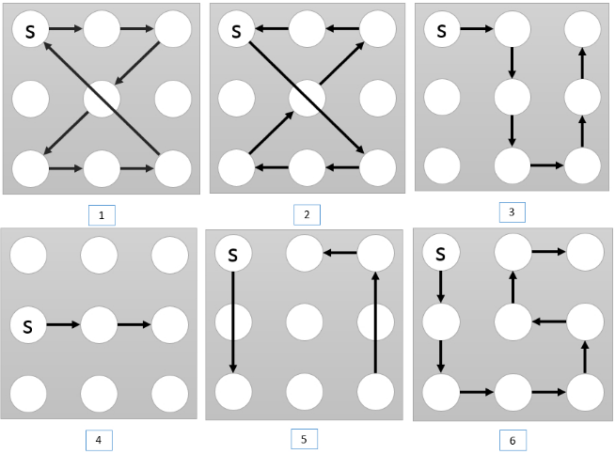

Android passcodes must satisfy the following constraint:

1. *The passcode must contain at least 4 dots.*
2. *The passcode must contain distinct dots, i.e. cannot use the same dot twice. (Passing over a dot is a separate case, see 4.)*
3. *The line formed by the segments must be continuous (no breaks).*
4. *For each move, if the line segment formed by the two dots passes over a third dot, then this third dot must have been linked up previously for the move to be valid.*

**Only patterns 3 and 6 satisfy these constraints.**

Pattern 1 violates constraint 2.

Pattern 2 violates constraint 4.

Pattern 4 violates constraint 1.

Pattern 5 violates constraint 3.

1. **A large tournament has 569 entrants in total. If it is a single elimination tournament, how many matches have to be played out before the champion can be decided? (Please calculate the precise value)**

*“A single-elimination, knockout, or sudden death tournament is a type of elimination tournament where the loser of each match-up is immediately eliminated from the tournament.”[1]*

For choosing a single winner at the end of the tournament, we first need to eliminate the other 568 entrants. Thus, **568** matches have to be played before the champion can be decided. ■

1. **The figure below shows a partial 4X4 matrix，is there some way of filling up the rest of the omitted entries to produce a magic square of size 4？**

$$\left[\begin{aligned}\begin{matrix}2 \\ 4\end{matrix}\begin{matrix}3 \\ \end{matrix}\begin{matrix} \\ \end{matrix}\begin{matrix} \\ \end{matrix} \\ \begin{matrix} \\ \end{matrix}\begin{matrix} \\ \end{matrix}\begin{matrix} \\ \end{matrix}\begin{matrix} \\ \end{matrix}\end{aligned}\right]$$

Let us regard the problem with variables representing the missing values:

$$\left[\begin{matrix}2 & 3 & c & d \\ 4 & f & g & h \\ i & j & k & l \\ m & n & o & p\end{matrix}\right]$$

We know that for a 4x4 magic square

$$M=\frac{n(n^{2}+1)}{2}=34$$

We have the following constraints for line 1 and column 1 respectively:

$$2+3+c+d=M=34 ⟹ c+d=29 \\ 2+4+i+m=M=34 ⟹ i+m=28$$

As all values are from the set

$$D=\left\{1,2,…,16\right\}∖\left\{2,3,4\right\}$$

we only have a few options:

$$\left(c,d\right)∈\left\{\left(14,15\right),\left(15,14\right),\left(13,16\right),\left(16,13\right)\right\}$$

$$\left(i,m\right)∈\left\{\left(12,16\right),\left(16,12\right),\left(13,15\right),\left(15,13\right)\right\}$$

The latter two values for $\left(c,d\right)$ will render all values for $\left(i,m\right)$ unavailable (as we can use a value only once). Thus:

$$\left(c,d\right)∈\left\{\left(14,15\right),\left(15,14\right)\right\}$$

$$\left(i,m\right)∈\left\{\left(12,16\right),\left(16,12\right)\right\}$$

From this, we know that

$$26≤d+m≤31$$

Not let us regard the magic square property for the second diagonal:

$$d+g+j+m=34$$

Using the previous inequality we get

$$3≤g+j≤8$$

Now let us regard the magic square property for the 2nd row and 2nd column:

$$4+f+g+h=34$$

$$3+f+j+n=34$$

Adding the together, we get:

$$2f+\left(g+j\right)+h+n=61$$

Applying the constrains for $\left(g+j\right)$ we get:

$$2f+h+n≥53$$

We’ve already used the following numbers: $2, 3, 4, 12, 14, 15, 16$. Thus, we get the largest value for the above expression if we use

$$f=13$$

$$h=11$$

$$n=10$$

But even in this case, we are unable to satisfy the constraint:

$$2f+h+n≤2∙13+11+10=47$$

Using the magic square constrains for 2 rows, 2 columns and 1 diagonal, and utilizing the fact that every variable must take up a unique value from $D$, we arrived at a contradiction. Thus magic squares of the given form do not exist. ■

1. Source: <https://en.wikipedia.org/wiki/Single-elimination_tournament>